Purpose: There are several steps and processes involved when mailing Caring Contact Cards This document will serve as a guide in detailing the differing steps and processes involved.
- Create an Excel spreadsheet
- Creating a Mail Merge
- Setting up Mailing Schedule
- General Information

Create as Excel Spreadsheet:
Step 1: Mail merging will require a list of suicidal individuals two whom you want to send messages. For example, you might want to include the following:
(Last 4, Salutation, First Name, Last Name, Birth Date, Gender, Address Street, Address City/St./Zip and Last Visit/Time Seen)
Last 4 | Salutation | First Name | Last Name | Birthdate | Gender | Address, Street | Address, City Zip | Last Visit

Step 2: You will also need column(s) to indicate when Caring Contacts need to be sent so you can sort or select the relevant suicidal individuals for that day or week’s letters (e.g., Day 1, Week 1, Month 1, Month 2, Month10…). These will be set up according to your Caring Contacts schedule.
Step 3: IMPORTANT: If you are importing the data for your spreadsheet from the electronic medical record or another system, check for duplicates and verify the addresses.
Locate the Find & Select in the excel toolbar located at the top of the spreadsheet:
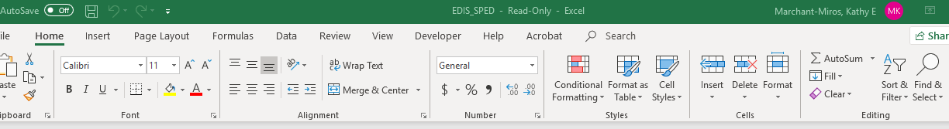
Select Find from the drop-down menu. Type the last name of the suicidal individual in the text box and select Find All: 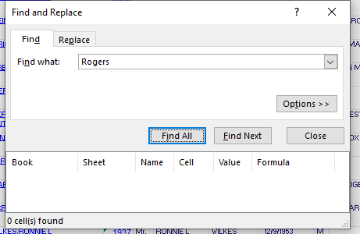
This will allow you to see repeat names. If they are a repeat case you can remove so they do not receive two contacts at the same time.
Step 4: For each suicidal individual, check to see if their postal address is correct. This may happen once, you may want to check after a regular interval (e.g., every six months), or you may need to check more regularly depending on the source of your address information.
If the suicidal individual is homeless without a viable address, cut and paste the information an “Inactive” worksheet so a Caring Contact is not prepared for them.
Step 5: When a suicidal individual has received all of the Caring Contacts in your schedule, they have completed the intervention. Move them to a “Completed” worksheet so you don’t continue to prepare cards for them. The Completed worksheet will also provide a list to check so as not to re-enroll an individual by accident.
Step 6: The names on the Active Tab are ones you will send Caring Contacts cards to. Enter the date you are sending the first card in a column under header like “CARD 1”.
- To auto populate the dates, highlight items in in the previous row and when you see a green box, place your cursor on the lower left side of the box until you see a + sign. You should be able to drag downward to populate the dates.

Step 7: Store the spreadsheet in a dedicated folder on your secure drive
(Do not store on desktop or personal drive)

Step 8: Print labels for appropriate suicidal individual on the list. You will need the following:
- Avery address labels #5660
- Study specific envelopes (often a colored envelope is used to stand out from other mail)
(LUX invitation envelopes with peel and press closure,
A6, 4 ¾ x 6 1/2, baby blue)
(items can be order from Home Depot)

Print 3 labels for each person as you will be creating the initial cards as well as the birthday and any other specific day cards (e.g., holiday, Veteran’s Day) in the same setting. Place the labels on the envelopes and make the lower right corner of the envelope with a 1, B or the month/day of the birthday. This will help if the card is returned. Mail the initial cards and file the others.

Creating a Mail Merge:
- Open the Word app open a blank document
- Click Mailings on the toolbar
- Click on the drop-down arrow on Start Mail Merge and choose labels
- Choose the labels you want (we use Avery 5660), click OK
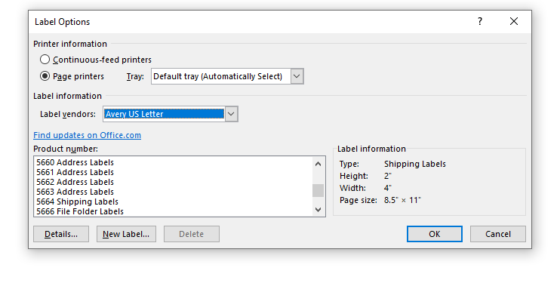
- Click on the drop-down arrow on Select Recipients from the toolbar and choose “use an existing list”

- Find your Excel document (tracking sheet) and click open
- While in the first label, click Insert Merge Field from the toolbar and select Salutation (space) click Insert Merge Field from the toolbar and select First_Name (space) click Insert Merge Field from the toolbar and select Last_Name and hit enter

- Click Insert Merge Field again and select Address_Street and hit enter
- Click Insert Merge Field again and select Address_City_St_Zip
- Click Update Labels on the toolbar.
- Click Finish and Merge and Edit Individual Documents
- Make sure that ALL is selected and click OK.

The word document containing the mail merge fields will automatically save as default to Document 1. You will need to change the name of the document to your document naming conventions.

- The document will populate with the label template. At the top of the document select Mailings, then select the Edit Recipient List.
A window will open with the Mail Merge Recipients.

- Click on the first check mark at the top of the document and deselect all names. This will allow you to scroll through the names until you find the Veterans you want to print labels for then select each one by checking the box and selecting OK.

- You will want to update the labels so scroll to toolbar at the top and select Update Labels.

- Select Finish & Merge, Edit Individual Documents, ensuring to select ALL, click OK.
This should populate the information on the labels. When you close the document select Don’t save.

Mailing Schedule
Below is a table you can edit to include the messages you want mailed to the suicidal individuals.
Schedule | Message
Week 1
Month 1
Month 2
Month 3
Month 4
Month 6
Month 8
Month 10
Month 12
Birthday
Holiday (if using)

GENERAL INFORMATION

Mailings:

Keep calendar reminders on days that you will need to mail cards (keeping in mind that some of the cards are NOT preprinted and you will have to print labels and do the cards for those.
- For those that are preprinted: Pull the cards, document as needed, and mail.
- For those that need to be printed: print the labels (ensuring you select the correct card), address the card “Dear Mr/Ms XWZ”, put the card in the envelope and in the lower right corner of the envelope write the number of the card (1,2,3 etc…), document as needed, and mail.

Returned Cards:
Every morning check for returned cards. Check to see if there is an alternate address. If there is, re-mail to that address; document on the spreadsheet that the card was sent to alternate mailing address and document as needed that the card was returned and re mailed to alternate address. (Indicate what address was used when re mailed, i.e. residential or permanent). If there is no other address to try, document on spreadsheet that card was returned, and no alt address was found. Move that person’s information to the Inactive sheet in the spreadsheet. Document as needed that the card that was returned, no alternative address found, and no additional cards will be mailed.
Birthday Cards:
On a select day (e.g., first of every month, every Monday) mail all the birthday cards for that period and document as needed.
Holiday Cards:
As these cards will go to everyone at once, give enough lead time to prepare and document so all can be mailed out close but prior to the specific day.
Intervention Completion:
When a Veteran has received a full year of cards they have completed the intervention. DO NOT re-enroll them accidentally. Move them to the complete tab in the tracker.

