U.S. Department of Veterans Affairs
Comprehensive Suicide Risk Evaluation (CSRE)
Printable Worksheet

The CSRE is utilized in the Veterans Health Administration to facilitate suicide risk evaluation following a positive screen for suicide risk or when otherwise clinically indicated. This worksheet includes the core components of the CSRE. For some items, spaces are provided to add details. Appendix A includes definitions (e.g., suicide attempt vs. preparatory behavior) and tips. Appendix B includes risk stratification guidance. Appendix C includes a full list of risk mitigation strategies.
Does the Veteran appear to be willing and able to answer questions related to the CSRE (consider intoxication, delirium or other factors that may impact responding)?
☐ If yes, proceed with worksheet
☐ If no, indicate reason and proceed with worksheet, documenting all available information, which will be used to make a final risk determination.
Reason: ______________________________________________________________

Suicidal Ideation
☐ How recently did thoughts occur?
Details of the ideation, including frequency: __________________________________________
______________________________________________________________________________
☐ Presence of intent: __Yes __No __Unknown/Unclear
______________________________________________________________________________
☐ Plan: __Yes __No __Unknown/Unclear
______________________________________________________________________________
☐ If most recent ideation is not the most severe ideation in the past 30 days, comment on details of the most severe ideation in the past 30 days, including frequency, intent and plan.
____________________________________________________________________________________
____________________________________________________________________________________
☐ Access to lethal means (specifically inquire about firearms and if present, you can comment on # and storage): _____________________________________________________________________________

Suicidal Behavior
Suicide Attempts
Note: If any suicidal behavior is already documented in a Suicide Behavior and Overdose Report (SBOR) or past CSRE, you will not have to document it again in the CSRE.

☐ Describe history of attempts, including #, general dates, and potential patterns (e.g., following argument with loved one, while intoxicated, after relapse, etc.)
____________________________________________________________________________________
____________________________________________________________________________________
☐ For the most recent attempt:
Date and method used: ___________________________________________________________
Was it interrupted: _______________________________________________________________
Was there any injury: _____________________________________________________________
Any care received afterwards: ______________________________________________________
Outpatient vs inpatient at the time, whether occurred on VA property and whether it occurred within 7 days of discharge from a VA inpatient or residential facility: _______________________
______________________________________________________________________________
☐ If the most recent attempt was not the most lethal, document the following for most lethal attempt:
Date and method used: ___________________________________________________________
Was it interrupted: _______________________________________________________________
Was there any injury: _____________________________________________________________
Any care received afterwards: ______________________________________________________
Outpatient vs inpatient at the time, whether occurred on VA property and whether it occurred within 7 days of discharge from a VA inpatient or residential facility: _______________________
______________________________________________________________________________

Preparatory Behavior
Note: Describe any preparatory behavior (1) not associated with any suicide attempts reported or (2) not previously reported in an SBOR or CSRE.
☐ Describe any preparatory behavior reported: ______________________________________________
☐ For most recent preparatory behavior:
Date and method the behavior was related to: ________________________________________
Outpatient vs inpatient at the time, whether occurred on VA property and whether it occurred within 7 days of discharge from a VA inpatient or residential facility: _______________________
______________________________________________________________________________

Warning Signs
☐ Warning signs currently present:
☐ Suicidal communication ☐ Hopelessness
☐ Preparations for suicide ☐ Increased isolation
☐ Seeking/recent use of lethal means ☐ Recklessness
☐ Anger ☐ Sleep disturbance
☐ Anxiety ☐ Escalating substance use
☐ Guilt or shame ☐ Other: ___________________
☐ Past warning signs (may inform safety planning): ___________________________________________
_____________________________________________________________________________________

Risk Factors
☐ History of suicide attempt
☐ Recent psychosocial stressors (e.g., homelessness; legal, financial, relationship problems)
☐ Access to lethal means (e.g., firearms, large quantities of medications)
☐ History of mental health hospitalizations (dates, reasons, duration)
☐ Psychological conditions or symptoms (e.g., mood/affective disorder, personality disorder, psychosis, insomnia, agitation, hopelessness)
☐ History of non-suicidal self-directed violence (e.g., cutting, burning)
☐ Losses (e.g., loss of a loved one or relationship)
☐ Medical conditions/health-related problems (e.g., TBI, HIV/AIDS, chronic pain)
☐ Member of minority group at risk for suicide (e.g., LGBT)
☐ Preexisting risk factors (e.g., history of trauma, history of suicide attempt)

☐ Recent transition from military to civilian life
☐ Other: _______________________________
☐ None Noted

Protective Factors and Reasons for Living
☐ Access to and engagement with health care (e.g., supportive medical care relationships)
☐ Motivation for medical treatment
☐ Access to and engagement with mental health care (e.g., supportive mental health care relationships)
☐ Motivation for mental health treatment
☐ Meaningful family relationships
☐ Significant other
☐ Child or other person-related responsibilities (e.g., elder)
☐ Hope for the future
☐ Protective personal traits or beliefs (e.g., pattern of help seeking, beliefs against suicide, cognitive flexibility)
☐ Religious or spiritual beliefs/connections
☐ Connections to cultural group (e.g., ethnic, religious, community, etc.)
☐ Social context support system (e.g., friend(s), community support)
☐ Strong desire to live
☐ Other: _______________________________
☐ None noted

Clinical Impressions (see Appendix B for Risk Stratification guide)
☐ ACUTE Risk for Suicide
☐ Low ☐ Intermediate ☐ High
Rationale: ______________________________________________________________________
☐ CHRONIC Risk for Suicide

☐ Low ☐ Intermediate ☐ High
Rationale: ______________________________________________________________________

Risk Mitigation Plan (see Appendix C for full list of risk mitigation strategies)
☐ Plan was developed in collaboration with:
☐ Veteran ☐ Family
☐ Veteran’s Guardian ☐ Additional health care providers
☐ Clinical setting in which CSRE was completed:
☐ ED/Urgent Care Center ☐ Outpatient (includes home, community)
☐ Inpatient ☐ Residential (includes CLC)
☐ Provide details of the plan: ____________________________________________________________

Appendix A

Definitions
Suicidal Ideation: Thoughts of engaging in suicide-related behavior.
Suicidal intent: There is past or present evidence (implicit or explicit) that an individual wishes to die, means to kill him/herself, and understands the probable consequences of his/her actions or potential actions. Suicidal intent can be determined retrospectively and in the absence of suicidal behavior.
Suicide Attempt: A non-fatal self-inflicted potentially injurious behavior with an intent to die as a result of the behavior.
Preparatory Behavior: Acts or preparation towards engaging in Suicidal Self-Directed Violence, but before potential for injury has begun. Examples include: writing a suicide note, stockpiling medications.
TIP: If there is potential for injury (e.g., pills have been ingested), the behavior is a suicide attempt; otherwise, it is preparatory behavior (e.g., pills are in the Veteran’s hand but have not been taken)
Warning Signs: Factors specific to the individual which when exacerbated or increase, signal an acute increase in risk of suicidal behavior in the immediate future (i.e., minutes and days). These can be assessed by asking the Veteran to describe thoughts, feelings, and behaviors experienced prior to most recent exacerbation of suicidal ideation or behavior. This information may inform safety planning, if indicated.
Risk factors: These increase the likelihood of engaging in suicidal self-directed violence. They may be modifiable or non-modifiable and both inform the formulation of risk for suicide. Modifiable risk factors may also be targets of intervention.
Protective factors: Capabilities, qualities, environmental and personal resources that drive an individual toward growth, stability, and health and may reduce the risk for suicide. Enhancing protective factors can be a target of intervention. Select all that apply. Each comment is optional, except if ‘Other’ is selected.

Risk Stratification and Risk Mitigation Plan Tips
Stratify the Veteran’s acute (minutes to days) and chronic (long-term) risk to inform disposition planning. Provide evidence for the acute and chronic risk levels, utilizing information obtained for the CSRE, and pay particular attention to the presence of warning signs and risk and protective factors.
In some circumstances (e.g., acute intoxication) acute and/or chronic risk may be difficult to determine. In these cases, consider a high risk level and detail the relevant circumstance in the evidence section.
See Attachment B for guidance on the risk stratification levels and associated risk mitigation steps to consider.

Appendix B
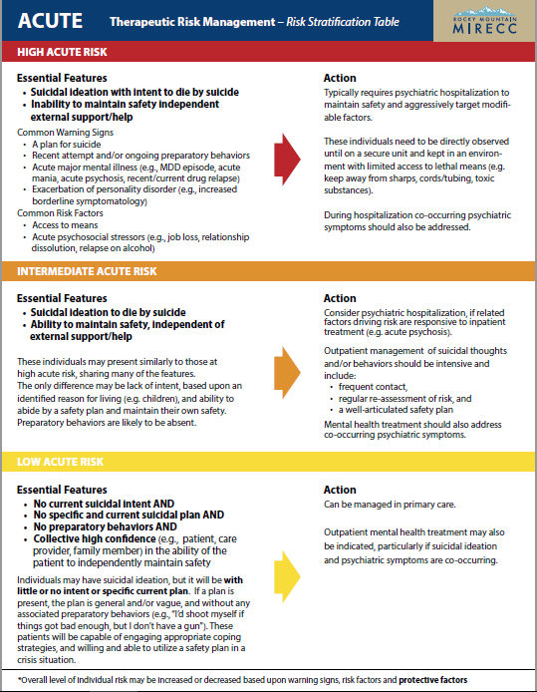
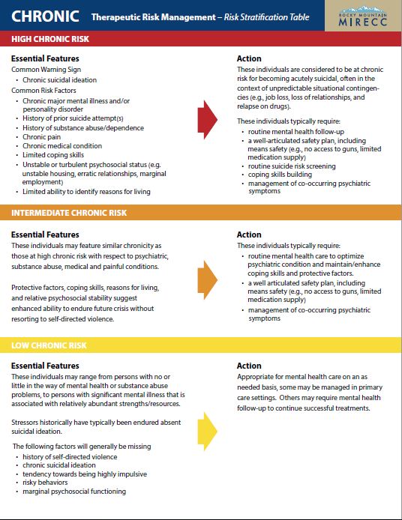

Appendix C

General Strategies to Mitigate Risk
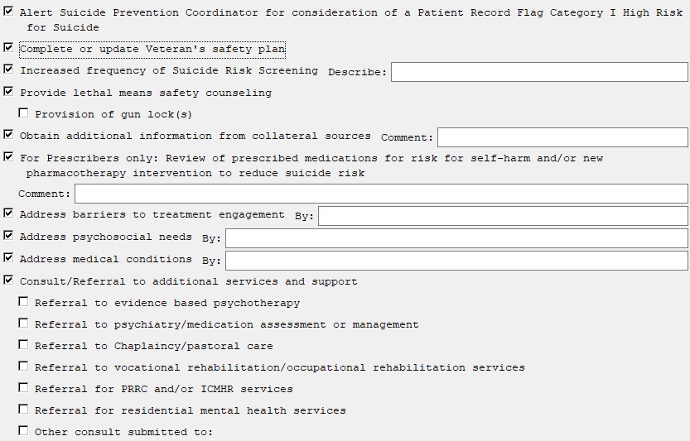
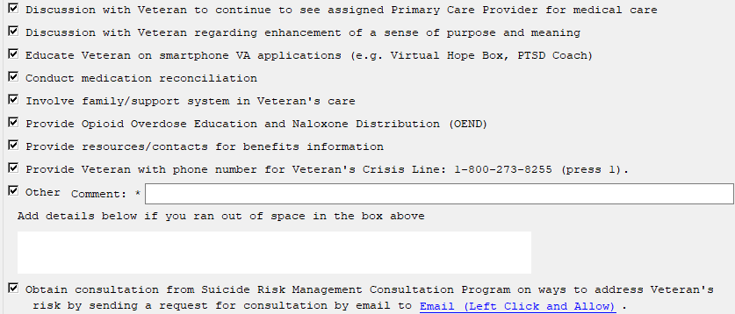

OUTPATIENT Risk Mitigation Strategies
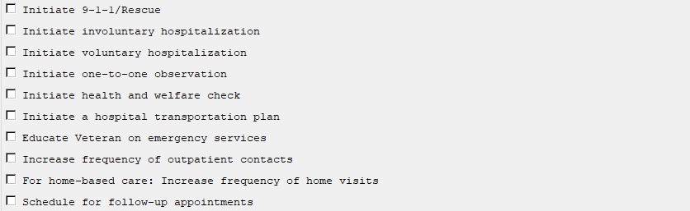

RESIDENTIAL Risk Mitigation Strategies
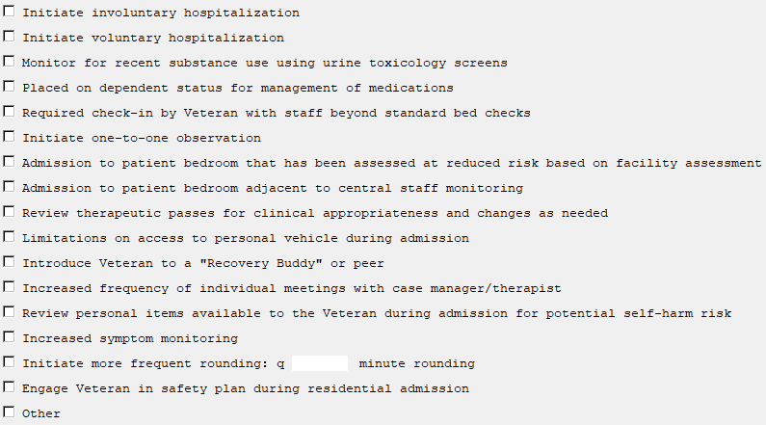

INPATIENT Risk Mitigation Strategies
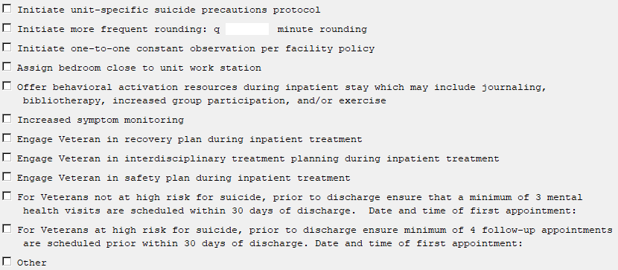

EMERGENCY DEPARTMENT/URGENT CARE CENTER Risk Mitigation Strategies
