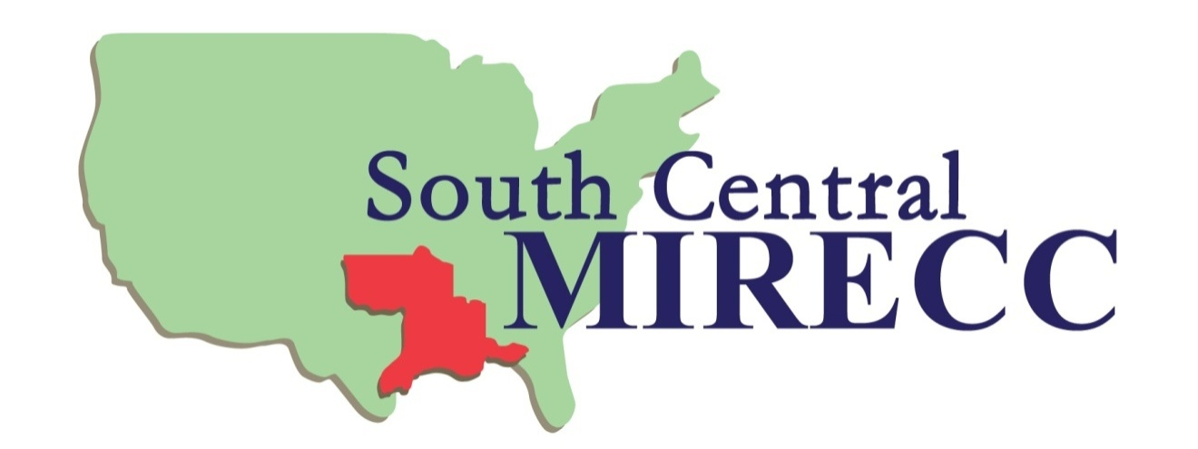

Announcing: 2021-2022 South Central MIRECC
Grant Writing Scholars Program
Description of the Program

This is the initial announcement and call for applications for the 2021-2022 South Central Mental Illness Research, Education and Clinical Center (SC MIRECC) Grant Writing Scholars (GWS) Program. This program provides a small number of investigators with didactic training and individualized mentoring in successful grant writing and is coordinated by Dr. Michael Cucciare, SC MIRECC Associate Director for Research Training. A small group of applicants selected for the program will write and submit a draft grant proposal in January 2022. Each draft proposal will be reviewed by two investigators (mid-career and senior) in the SC MIRECC to provide helpful advice to strengthen the application, and then discussed via teleconference with the grant writer for individualized feedback. In late February 2022, the grant writers will attend a one-day didactic workshop featuring Dr. Geoffrey Curran, Professor, Departments of Pharmacy Practice and Psychiatry; Director, Center for Implementation Research University of Arkansas for Medical Sciences; and Senior Research Health Scientist, North Little Rock Health Services Research and Development Service (HSR&D), Center of Innovation, Central Arkansas Veterans Healthcare System, and Dr. Ellen Fischer, Associate Professor, Department of Psychiatry & Behavioral Science, and Department of Epidemiology, University of Arkansas for Medical Sciences; SC MIRECC Assistant Director for Research; and Senior Research Health Scientist, North Little Rock HSR&D Center of Innovation, Central Arkansas Veterans Healthcare System. This program has received outstanding ratings, and most past participants have been subsequently successful in obtaining funding. The workshop will either be held in-person (most likely) in Little Rock or Houston or virtually by videoconference.

Who Can Participate?

Eligible applicants are SC MIRECC affiliates, postdoctoral fellows, and other investigators interested in becoming involved with the SC MIRECC. This program is appropriate for persons at postdoctoral, instructor, and assistant professor levels who are ready to write applications for national funding sources such as VA Merit Review and the National Institutes of Health (not for local pilot projects). Past participants have included new grant writers and investigators who have some experience but who need additional mentoring to achieve a successful application. Career development award proposals may be submitted; for these, the reviews will focus on the research plan. Preference will be given to applicants whose work is consistent with the SC MIRECC’s mission, “to promote equity in engagement, access, and quality of mental health care for Veterans facing barriers to care, especially rural Veterans.” Each applicant will identify a SC MIRECC site leader or MIRECC senior investigator at their site to be their SC MIRECC sponsor. Sponsors assist the grant writers with understanding the SC MIRECC mission and with logistics such as travel arrangements and communications with SC MIRECC during and after the GWS program. Sponsors do not have to be experts in the area of research for the proposed grant nor do they need to be a mentor or Co-Investigator on the proposal. Contact information for SC MIRECC facility site leaders is provided at the end of this announcement. Interested applicants at facilities that do not have a SC MIRECC site leader should contact the GWS Program Director Dr. Michael Cucciare (see contact information below).

Potential applicants for the GWS program may need to discuss their participation with their supervisor and VA service line chief or department chair, as applicable. Completing the draft proposal and then the final proposal will require a significant investment of time and effort, and grant writers may need to negotiate time to work on research. Applicants also need to determine that there is institutional support for the research they are proposing. Applicants who are new to the grant-writing process should discuss realistic time commitment expectations with their SC MIRECC sponsor or senior investigators.

Application Process

Completed applications will be accepted at any time but due no later than October 15, 2021; draft grant applications will be due January 7, 2022. The application (attached) requests preliminary information about the proposed topic, objectives, and funding agency to help us identify appropriate reviewers for the draft proposal. Selection criteria will include the applicant’s demonstrated interest in development of a research career and grant writing, innovativeness or creativity of the proposed project, and potential of the proposal to become a fundable project. The application and applicant’s CV should be emailed to Penny White (contact information below). We will plan to notify successful applicants soon after receiving applications but no later than November 1, 2021.

Please contact the program director, Dr. Michael Cucciare (contact information below) if you have questions and need more information.

GWS Program Contact Information:
Penny White (16MIR/NLR)
South Central MIRECC
2200 Fort Roots Drive, Bldg. 58
North Little Rock, AR 72114
Phone: (501) 257-1797
Fax: (501) 257-1718
Email: penny.white@va.gov

Site Leaders

New Orleans: laurel.franklin@va.gov

Little Rock: jeffrey.pyne@va.gov

Houston: lilian.dindo@va.gov

GWS Program Director

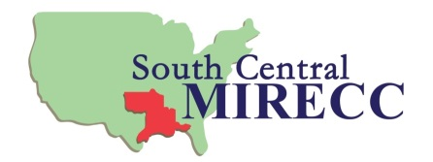
macucciare@uams.edu or 501-526-8179
APPLICATION for SC MIRECC

GRANT WRITING SCHOLARS 2021-2022

(Must be received by close of business 10/15/2021)

Name:

Current Title/Position/Affiliation(s):

Full Mailing Address:

Phone:
Fax:
Email address:

Proposed Title/Topic of Research Application:

Include a BRIEF description of the proposed project objectives to help us identify appropriate reviewers. DO NOT EXCEED 10 lines with font size 12. Please be sure your name is on all documents attached.

Possible funding sources being considered for the proposed research:

Applicant Signature: ___________________________________________Date:_______

------------------------------------------------------------------------------------------------------------
MIRECC Sponsor Endorsement:

Sponsor name:

Sponsor email address:

I agree to sponsor the applicant for the 2021-2022 Grant Writing Scholars Program. I will assist the grant writer as needed in learning about the SC MIRECC, making arrangements for travel/participation in the didactic training, and facilitate communications between the applicant and the SC MIRECC.

Signature: ___________________________________________________Date:_______

Applicant: PLEASE INCLUDE YOUR CV WITH THE APPLICATION
Send to: Penny.White@va.gov

